**1. Общие функции**

1.2 CREATE OR REPLACE FUNCTION random (a int, b int)

RETURNS int AS $$

DECLARE

res int;

BEGIN

res = random() * (b - a + 1) + a;

return res;

END;

$$ LANGUAGE PLPGSQL;

select * from random(-12,1)

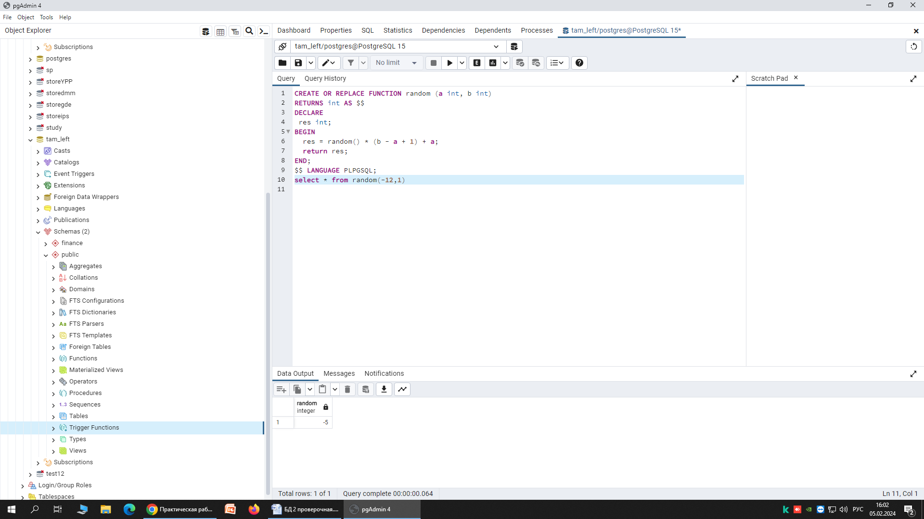

1.2 CREATE OR REPLACE FUNCTION random_double (a int, b int, p int)

RETURNS decimal AS $$

DECLARE

num decimal;

res decimal;

BEGIN

num = random() * (b - a)+a;

select Round(num,p) into res;

return res;

END;

$$ LANGUAGE PLPGSQL;

select * from random_double(1,11,2)

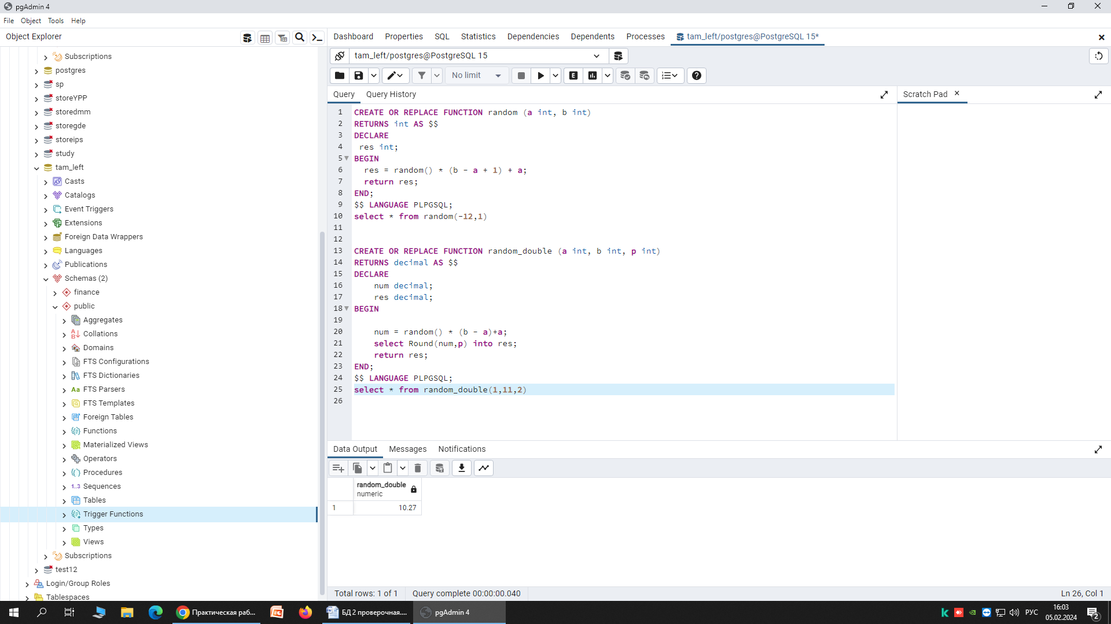

**2. Функции, работающие с массивами**

2.1 CREATE OR REPLACE FUNCTION mult_arr(arr numeric[], k int)

RETURNS decimal[] AS $$

DECLARE

x int;

BEGIN

FOREACH x IN ARRAY arr

LOOP

arr[x]:=arr[x]*k;

END LOOP;

return arr;

END;

$$ LANGUAGE PLPGSQL;

select * from mult_arr('{1.23,2.34,3.45}',2)

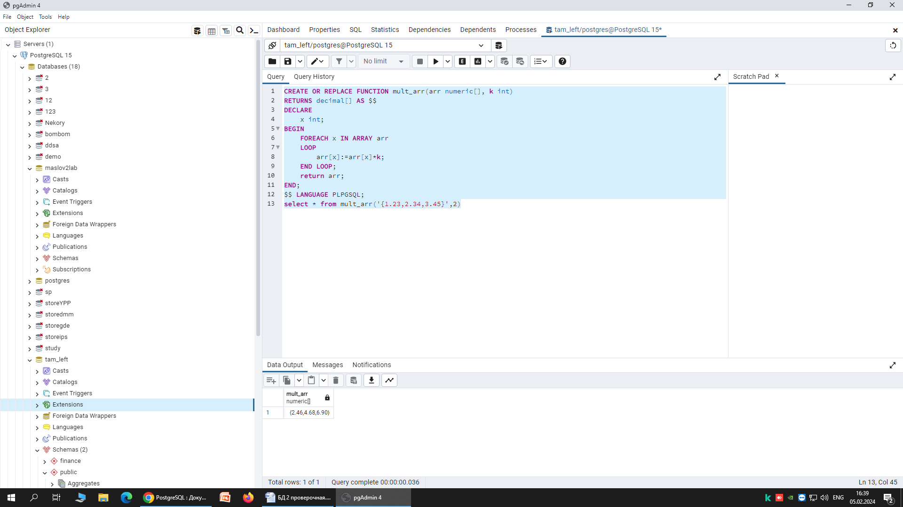

2.2 create or replace function get_arr(s text, n numeric, i integer)

returns text[] as $$

declare

arr text[];

begin

arr := array[s, n::text, i::text];

return arr;

end;

$$ language plpgsql;

select * from get_arr('привет',1.23,4)

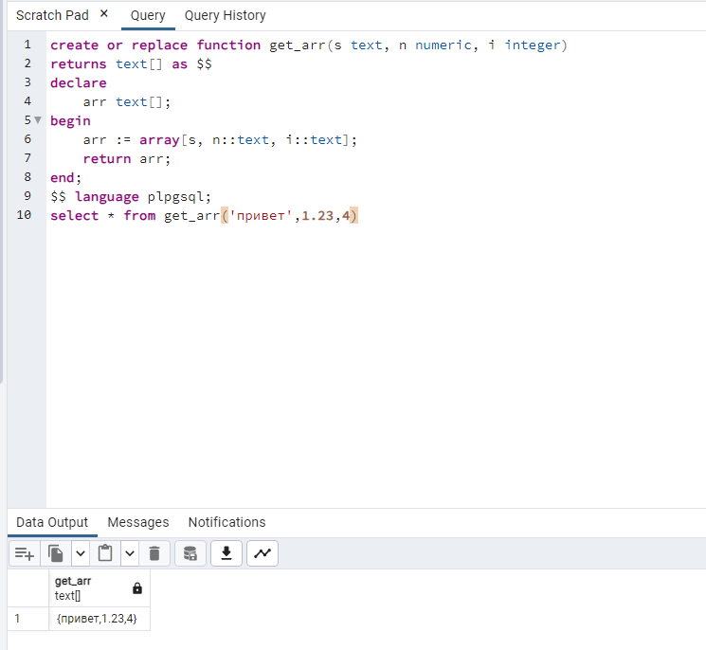

**3. Функции с произвольным числом аргументов**

3.1 CREATE OR REPLACE FUNCTION calculate(VARIADIC arr numeric[], out qty int, out summ numeric, out avgg numeric)

AS $$

SELECT cardinality(arr),sum(arr[i]), Round(avg(arr[i]),2) FROM generate_subscripts(arr, 1) g(i);

$$ LANGUAGE SQL;

SELECT calculate(10, 1.2, 0, -2, 7, -9.4);

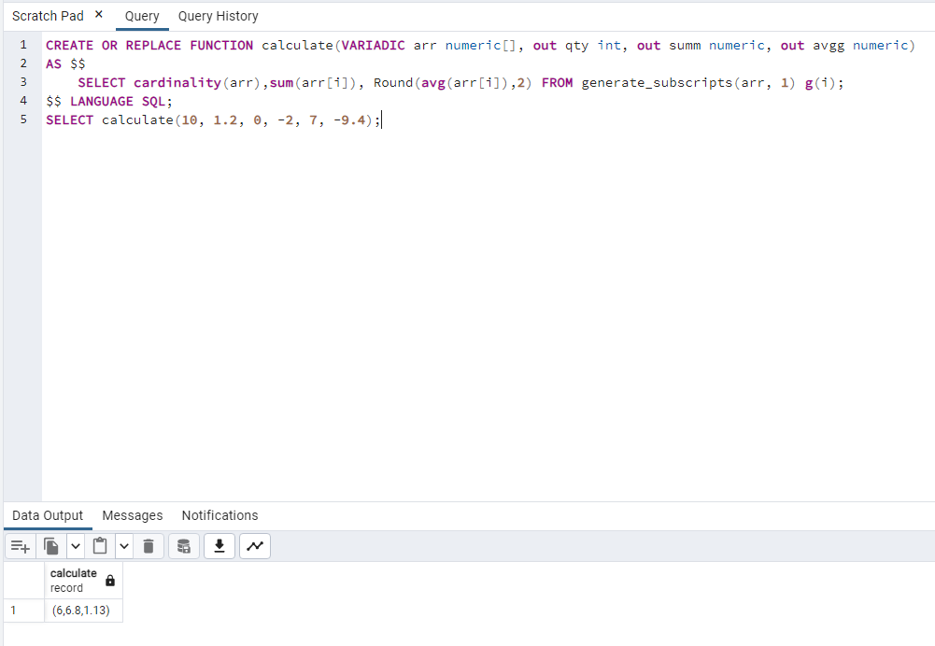

**4. Функции и процедуры для выполнения CRUD-операций (общая база данных)**

4.1 create or replace procedure pr_add_category(name varchar(50))

language plpgsql as $$

begin

insert into products (name) values (name);

end;

$$;

call pr_add_category('Капуста')

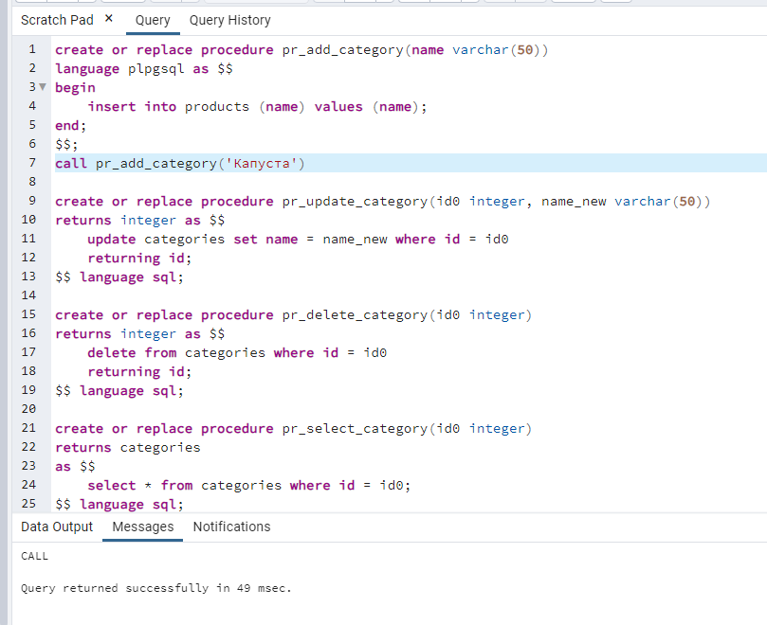

create or replace procedure pr_update_category(cur_id integer, name_new varchar(50))

language plpgsql as $$

begin

update products set name = name_new where id = cur_id;

end;

$$;

call pr_update_category(5,'Бананы')

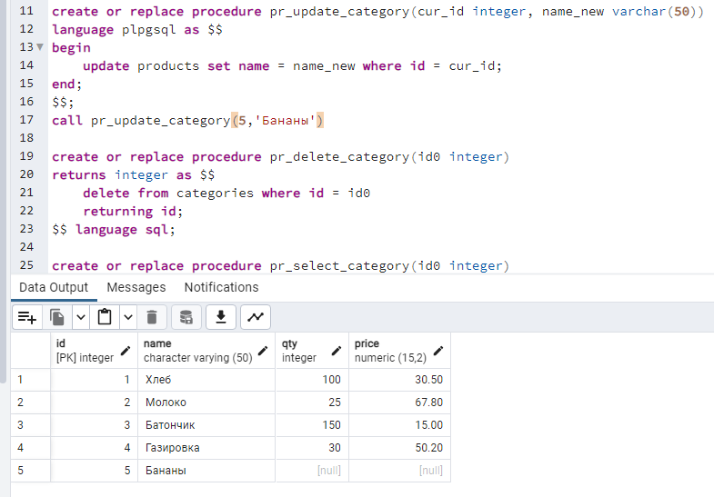

create or replace procedure pr_delete_category(cur_id integer)

language plpgsql as $$

begin

delete from products where id = cur_id;

end;

$$;

call pr_delete_category(5)

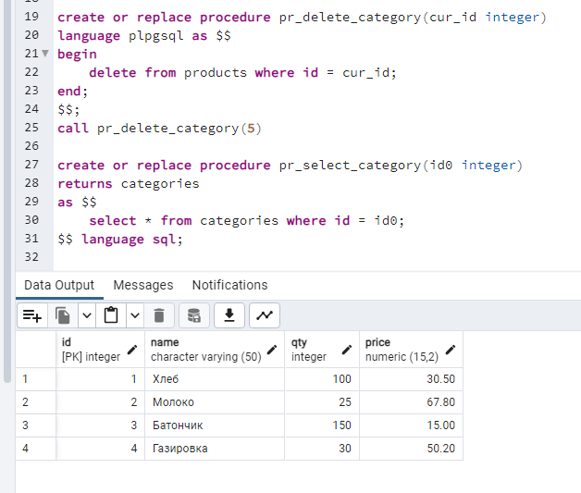

create or replace procedure pr_select_category(cur_id integer)

language plpgsql as $$

begin

perform * FROM products where id = cur_id;

end;

$$;

call pr_select_category(3)

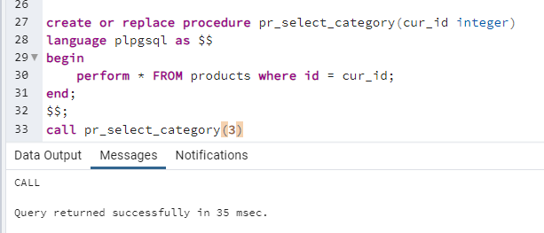

4.2 create or replace function f_add_category(name varchar(50))

returns varchar(50) as $$

begin

insert into products (name) values (name);

return name;

end;

$$ language plpgsql;

select from f_add_category('Капуста')

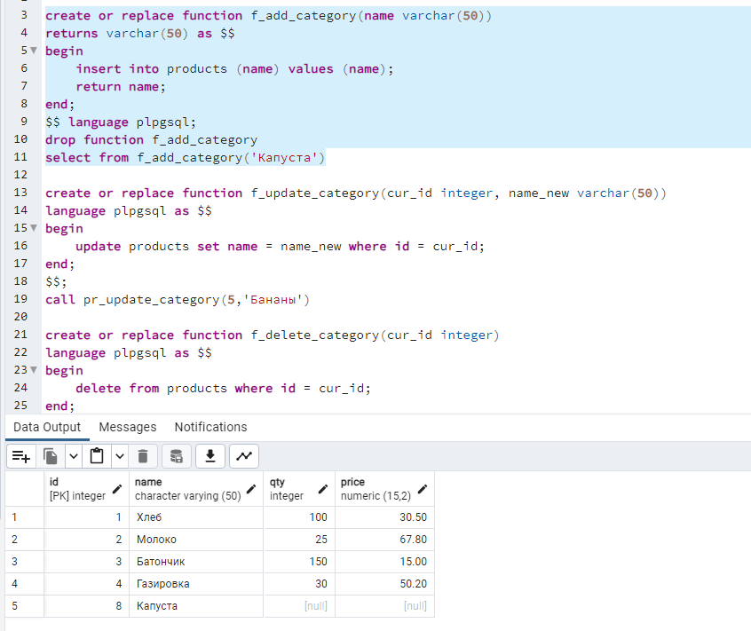

create or replace function f_update_category(cur_id integer, name_new varchar(50))

returns boolean as $$

begin

update products set name = name_new where id = cur_id;

return true;

end;

$$ language plpgsql;

select from f_update_category(8,'Бананы')

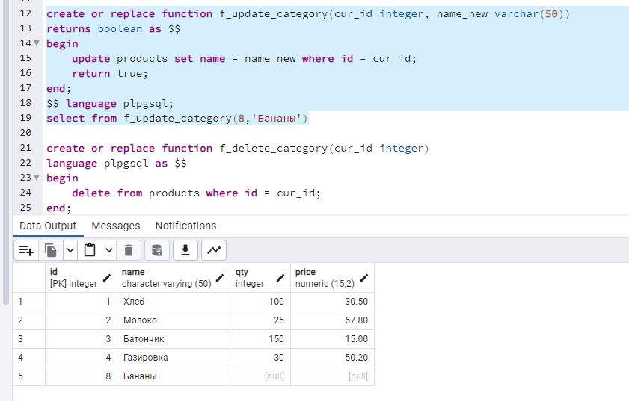

create or replace function f_delete_category(cur_id integer)

returns boolean as $$

begin

delete from products where id = cur_id;

return 1;

end;

$$ language plpgsql;

select from f_delete_category(8)

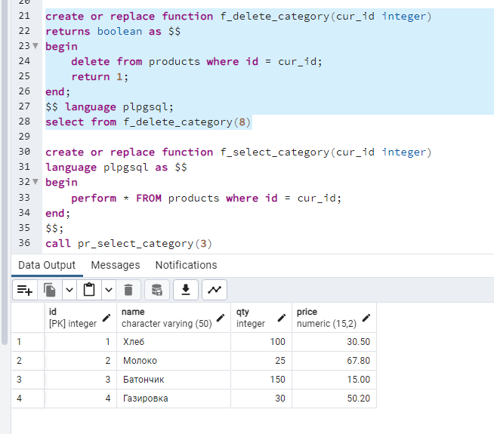

create or replace function f_select_category(cur_id integer)

returns products

as $$

select * from products where id = cur_id;

$$ language sql;

select f_select_category(3);

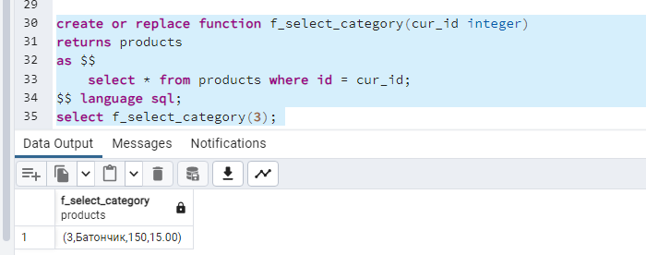

1. Добавляет новую запись
2. Использование if not exist
3. 1
4. 1
5. select f_select_category(3); - вывод массивом

select * from f_select_category(3); - вывод таблицей

select (f_select_category(3)).id, (f_select_category(3)).name; - вывод id и name

1. Вызвать можно, функция вернёт значение Boolean

**5. Функции, возвращающие множество значений и таблицу**

5.1 create or replace function list()

returns setof text as $$

select * from products where qty = 0 or qty is null;

$$ language sql;